Chennai Property Buying s Rental SaaS
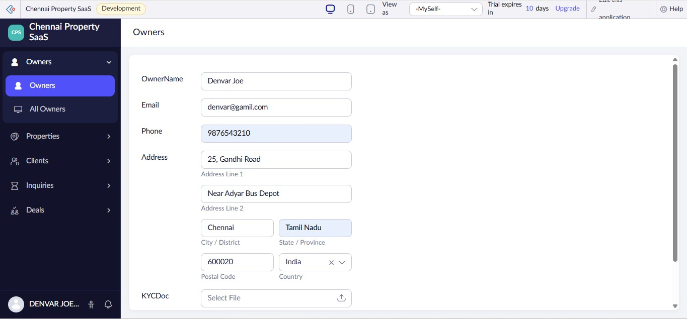
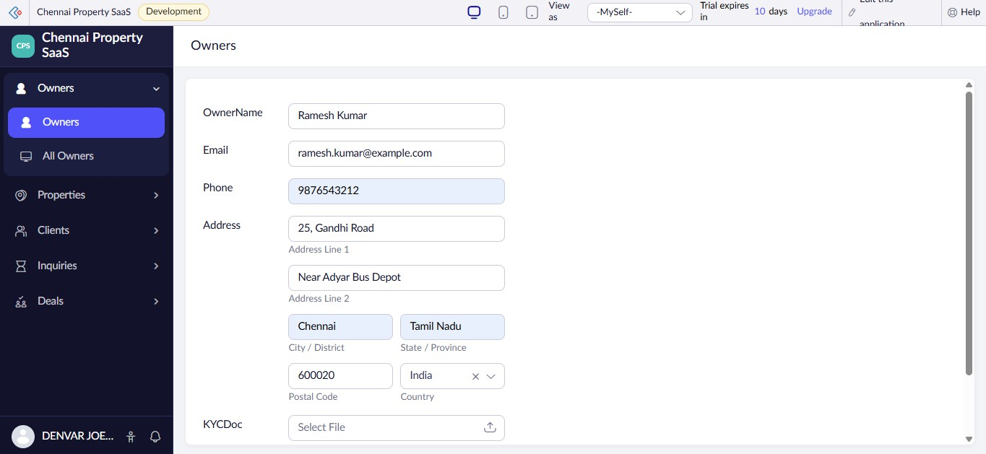
Name:JAGADEESH A
Reg no:192521294

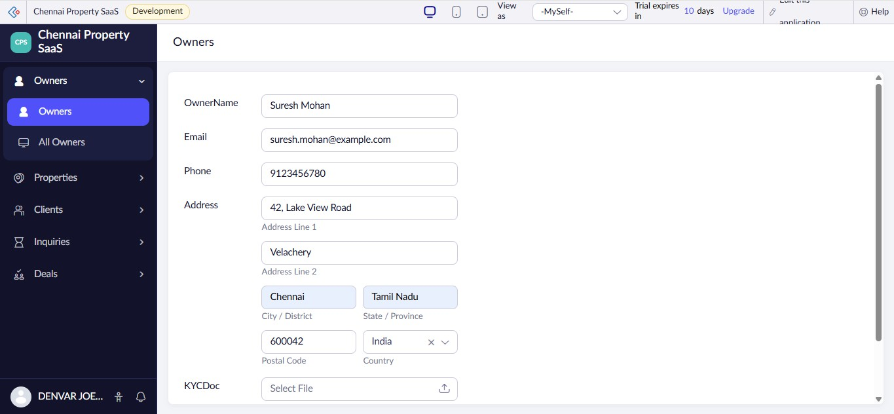
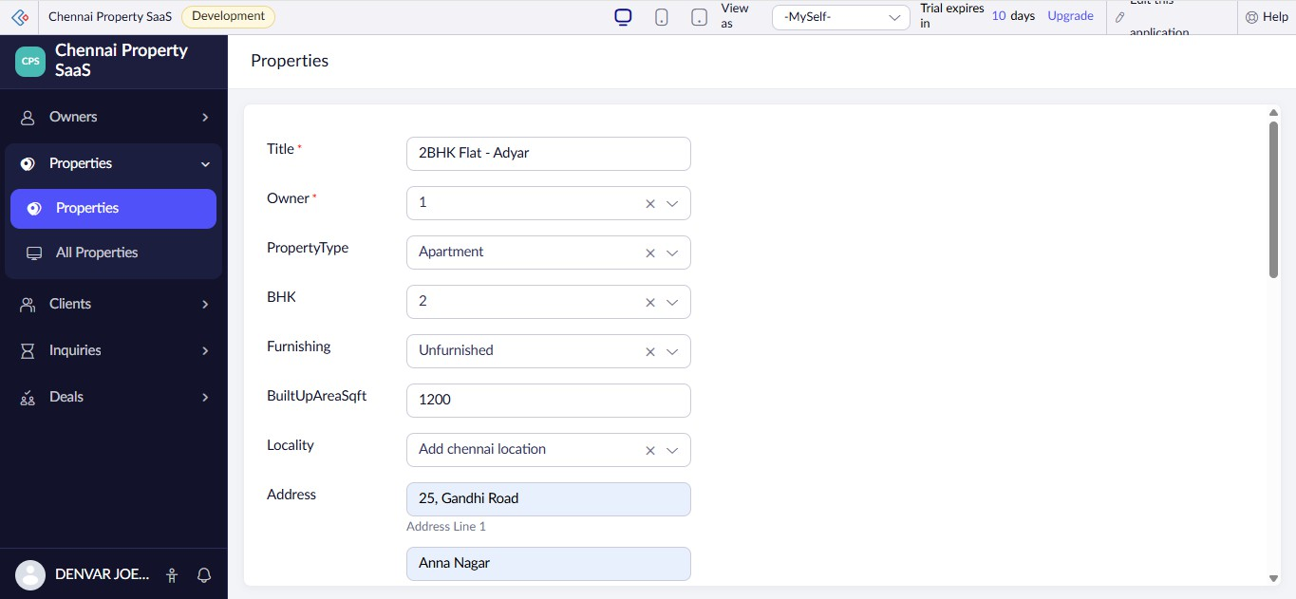
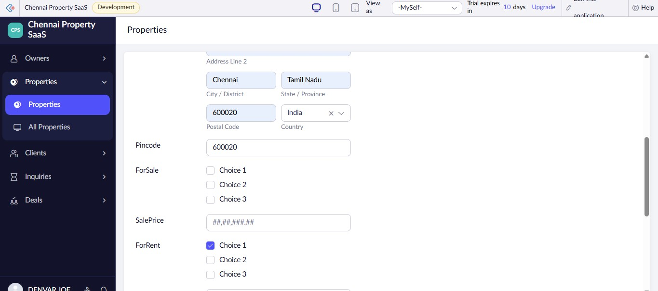

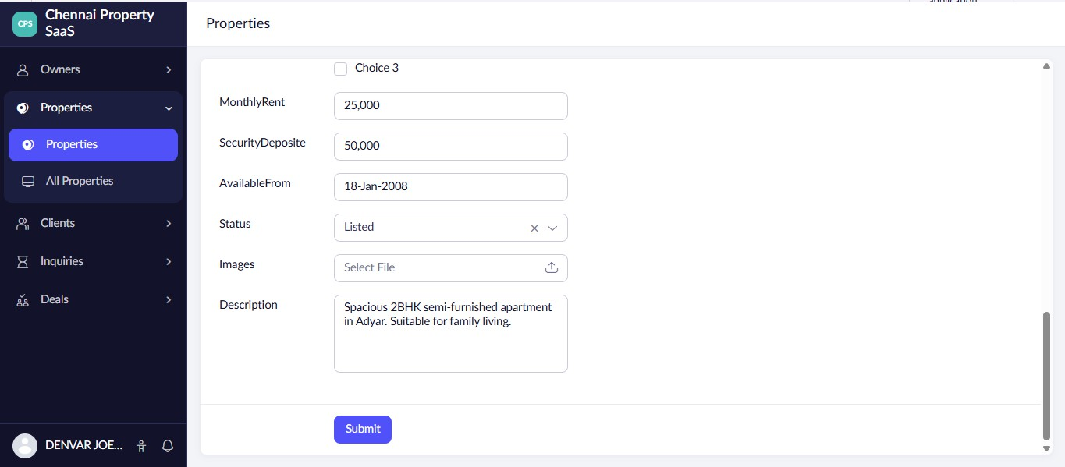
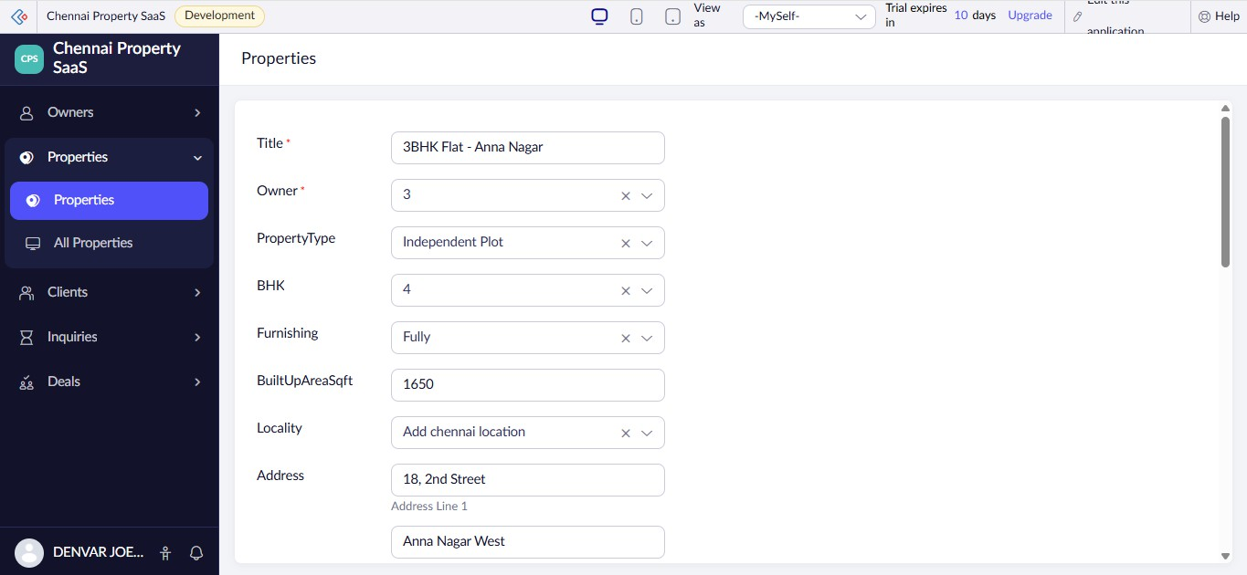
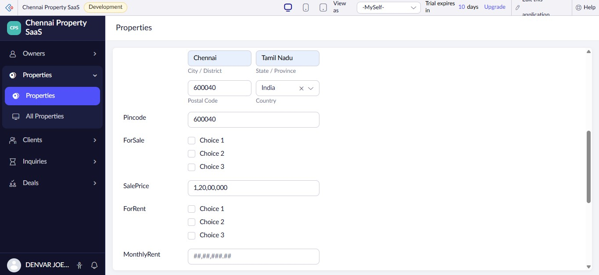

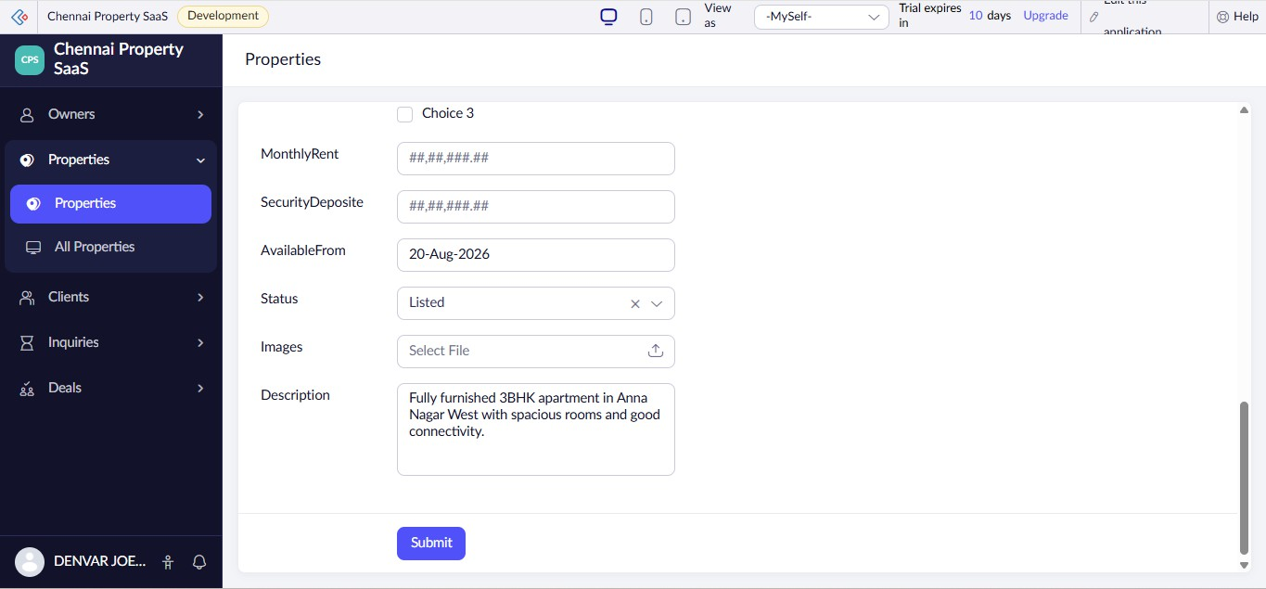
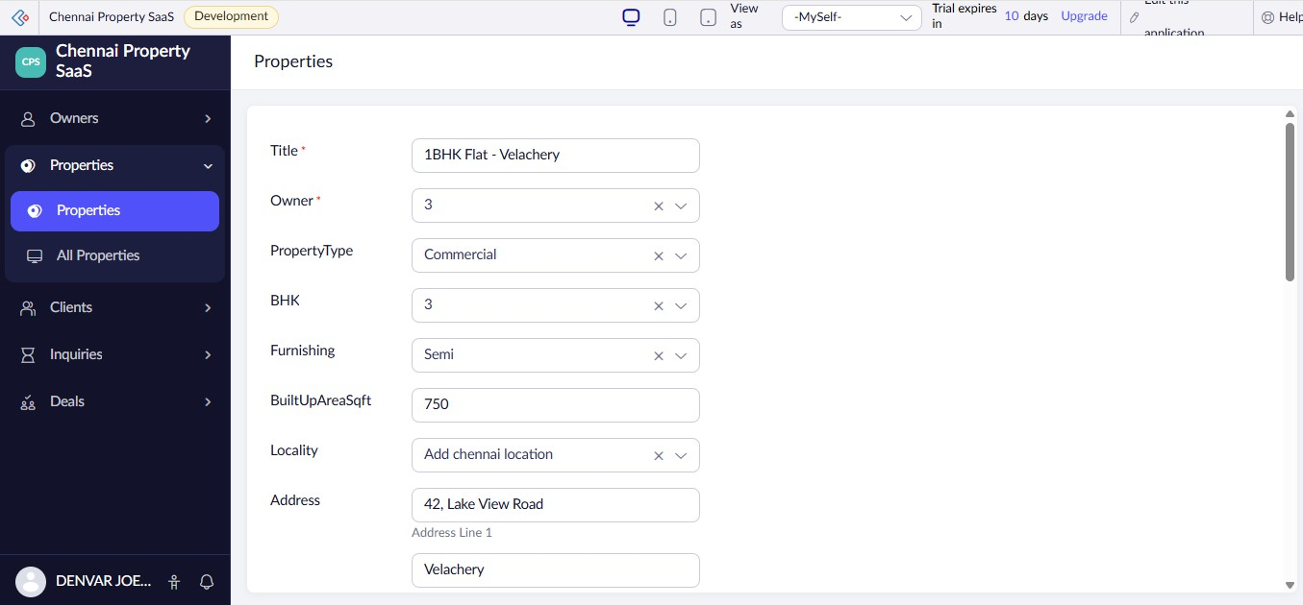
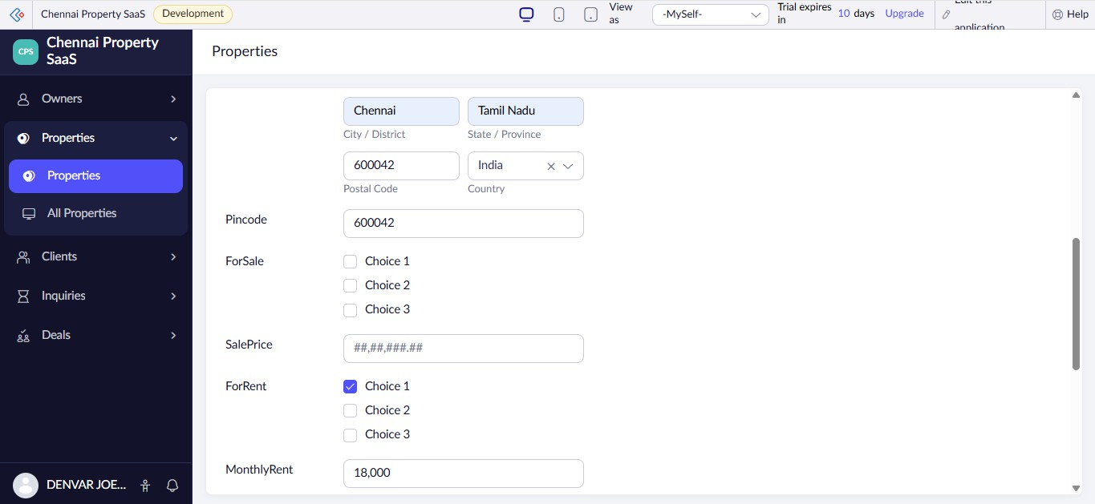

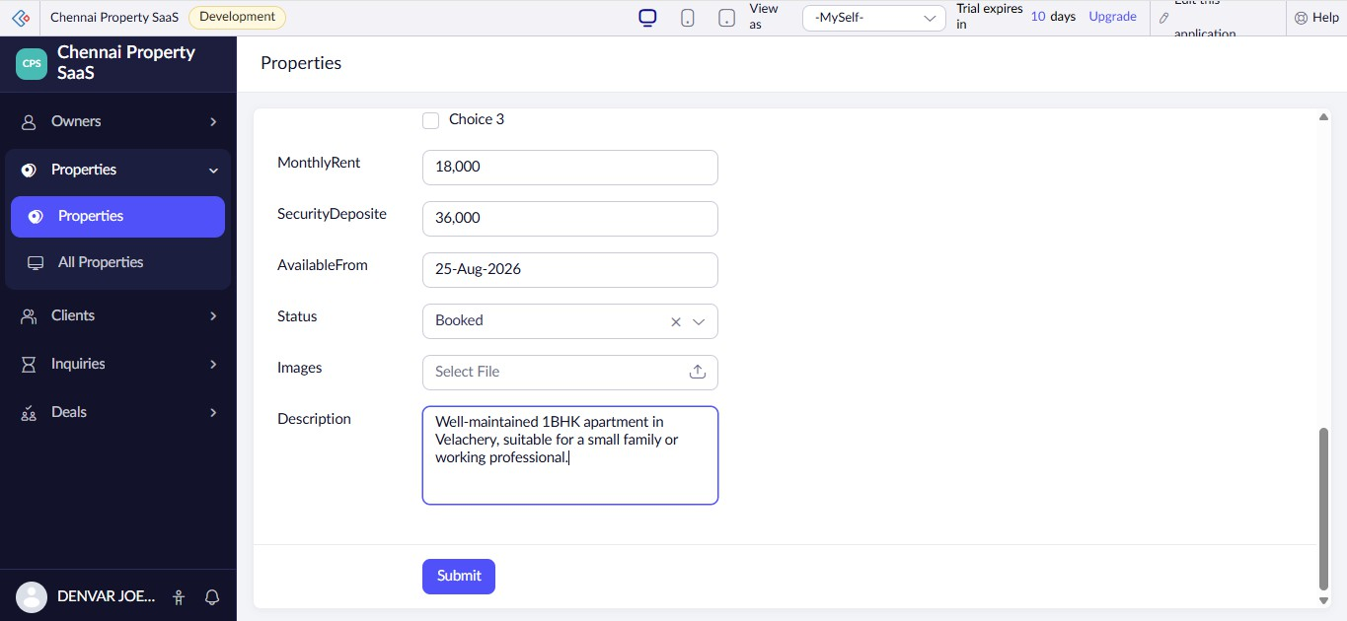
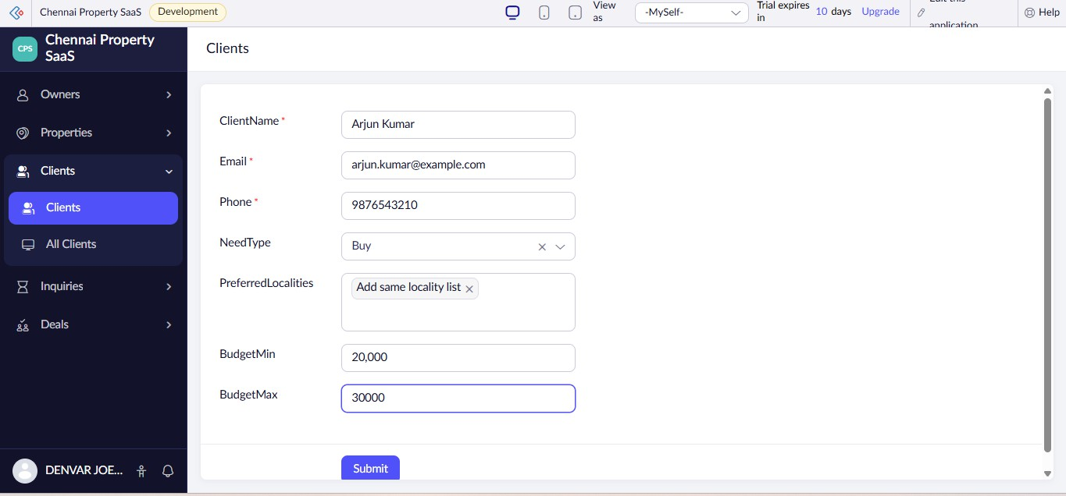
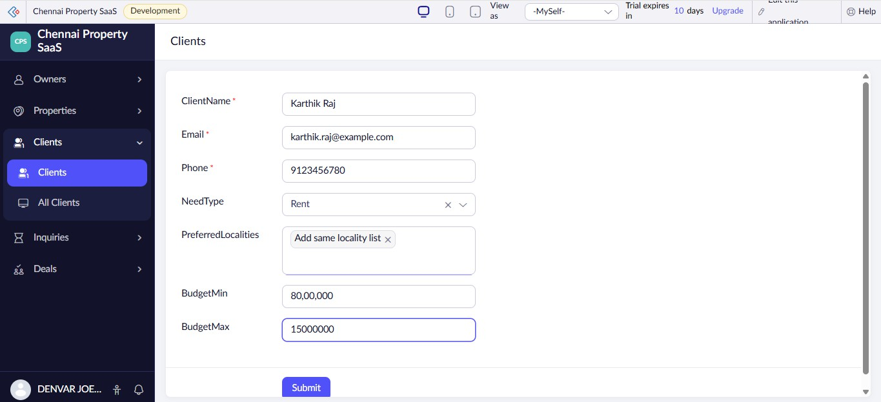

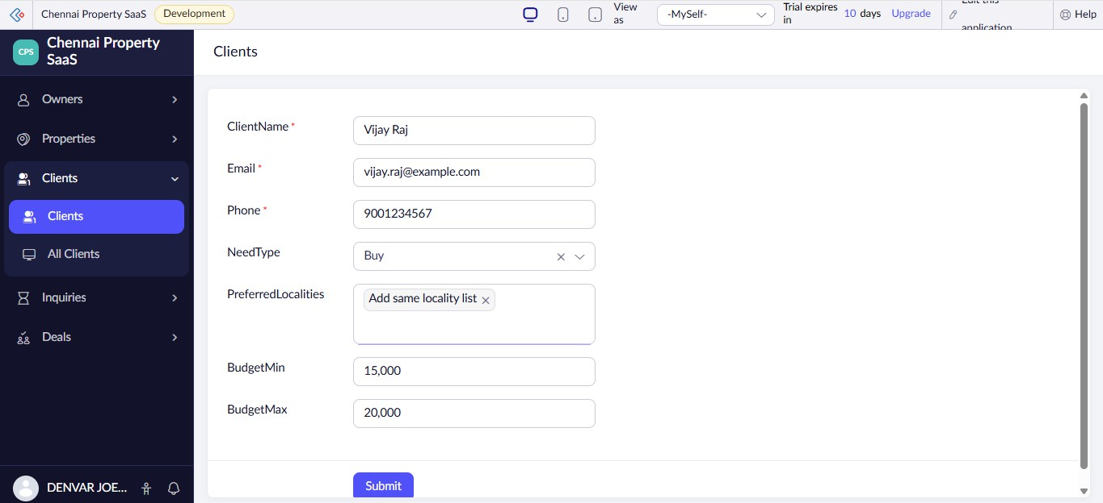
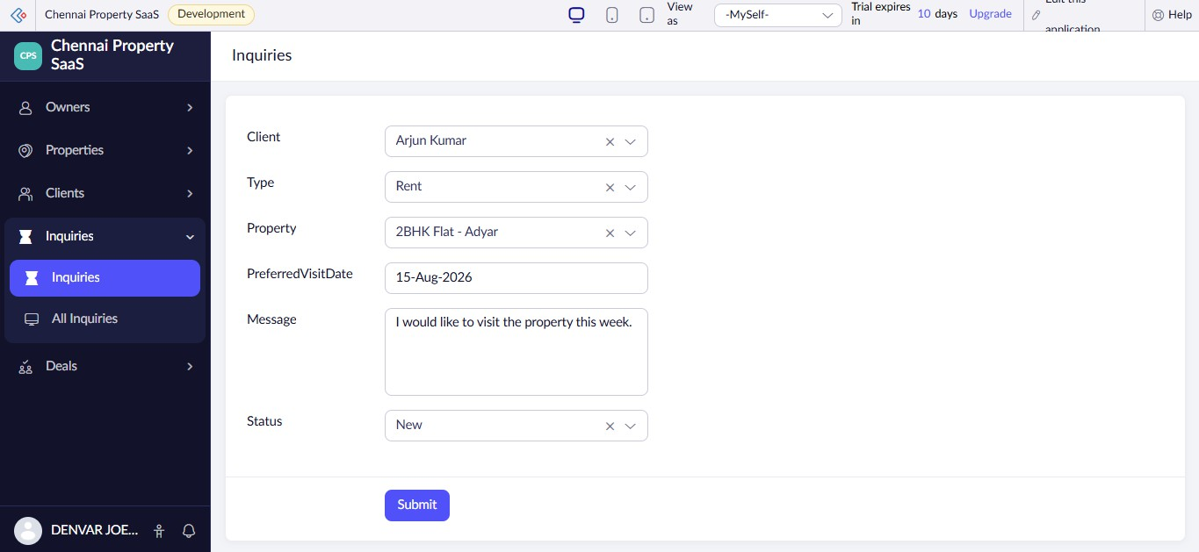
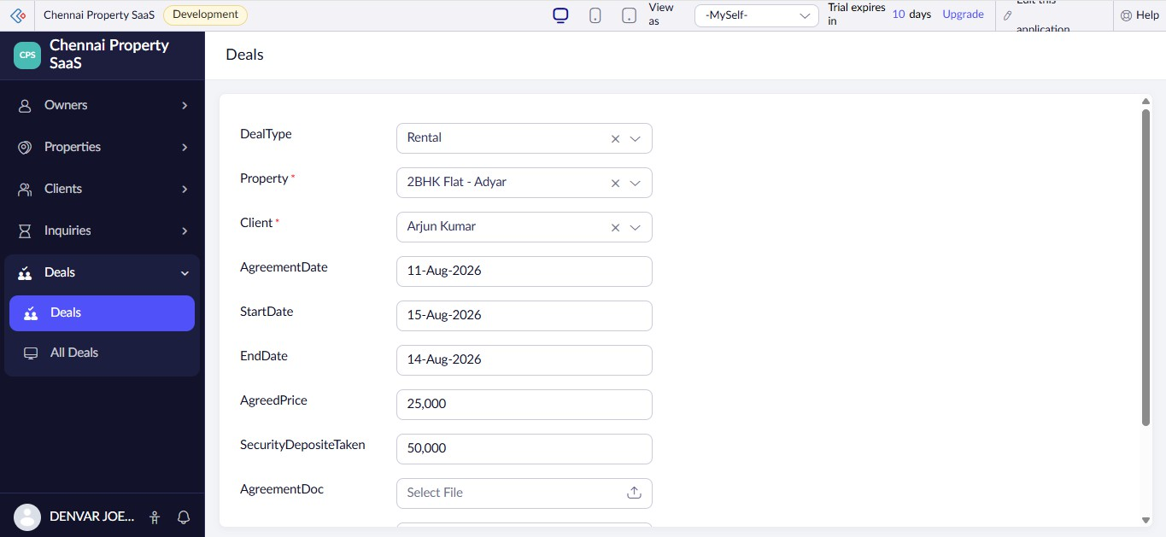

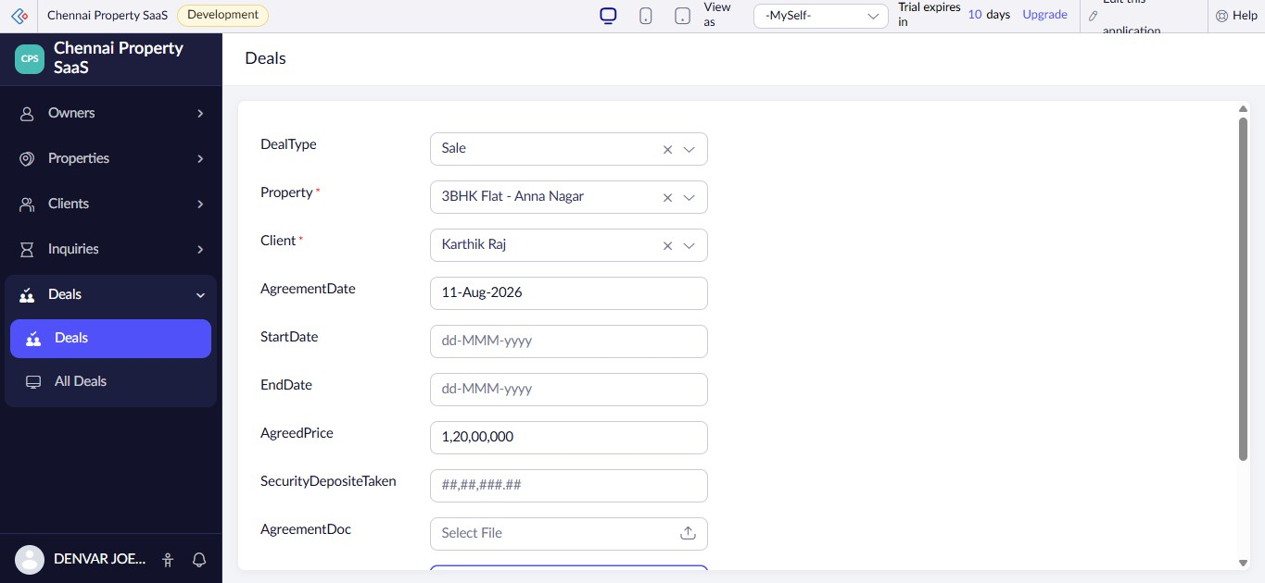
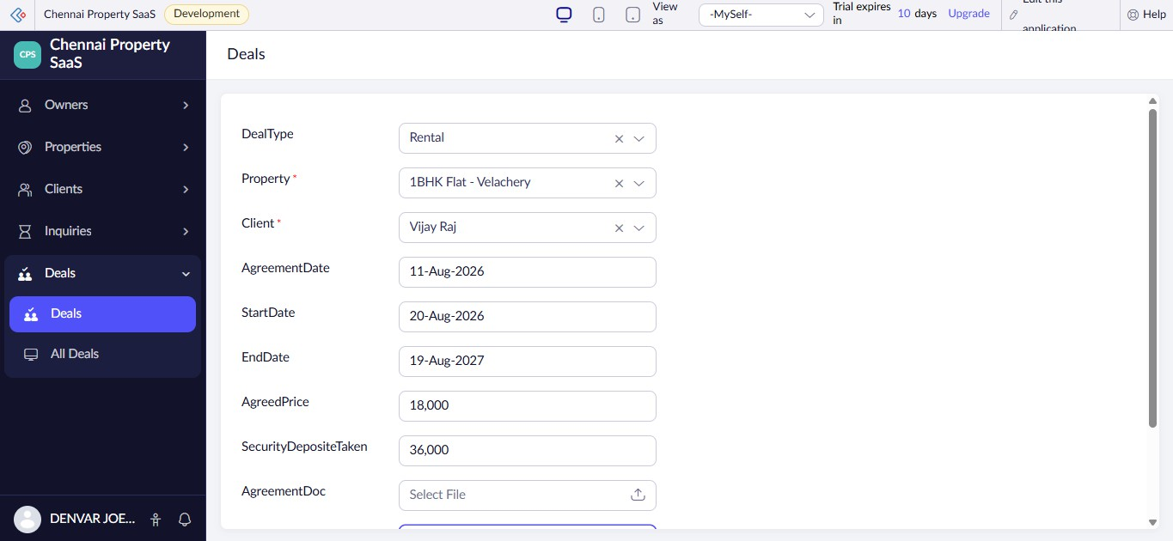
All Owners
OwnerName
Email
Phone

OwnerID | OwnerName Email Phone |  |  | Address | KYCDoc
3 | Suresh Mohan | suresh.mohan@example.com | 9123456780 | @ 42, Lake View Road, Velachery, Chennai, Tamil Nadu, 600042, India
2 | Ramesh Kumar | ramesh.kumar@example.com | 9876543212 | @ 25, Gandhi Road, Near Adyar Bus Depot, Chennai, Tamil Nadu, 600020, India
1 | Denvar Joe | denvar@gamil.com | 9876543210 | @ 25, Gandhi Road, Near Adyar Bus Depot, Chennai, Tamil Nadu, 600020, India

All Properties
Title
Owner
PropertyType
BHK
Furnishing

PropertyID | Title | Owner | PropertyType | BHK | Furnishing | BuiltUpAreaSqft
3 | 1BHK Flat - Velachery | 3 | Commercial | 3 | Semi | 750
2 | 3BHK Flat - Anna Nagar | 3 | Independent Plot | 4 | Fully | 1650
1 | 2BHK Flat - Adyar | 1 | Apartment | 2 | Unfurnished | 1200

All Clients
ClientName
Email
Phone
NeedType
PreferredLocalities

ClientID | ClientName Email Phone NeedType PreferredLocalities |  |  |  |  | BudgetMin
3 | Vijay Raj | vijay.raj@example.com | 9001234567 | Buy | Add same locality list | ₹ 15,000.00
2 | Karthik Raj | karthik.raj@example.com | 9123456780 | Rent | Add same locality list | ₹ 80,00,000.00
1 | Arjun Kumar | arjun.kumar@example.com | 9876543210 | Buy | Add same locality list | ₹ 20,000.00

All Inquiries
Client
Type
Message

InquiryID | Client Type |  | Message | Status | Property | PreferredVisitDate
3 | Vijay Raj | Rent | I am interested in this rental property. Please arrange a site visit. | New | 1BHK Flat - Velachery | 20-Aug-2026
2 | Karthik Raj | Buy | I am interested in purchasing this property and would like to schedule a visit. | Contacted | 3BHK Flat - Anna Nagar | 17-Aug-2026
1 | Arjun Kumar | Rent | I would like to visit the property this week. | New | 2BHK Flat - Adyar | 15-Aug-2026

All Deals
DealType
Property
Client
AgreementDate
StartDate

DealID | DealType | Property | Client | AgreementDate | StartDate | EndDate
3 | Rental | 1BHK Flat - Velachery | Vijay Raj | 11-Aug-2026 | 20-Aug-2026 | 19-Aug-2027
2 | Sale | 3BHK Flat - Anna Nagar | Karthik Raj | 11-Aug-2026
1 | Rental | 2BHK Flat - Adyar | Arjun Kumar | 11-Aug-2026 | 15-Aug-2026 | 14-Aug-2026

